Abstract
The project entitled as ” Brain Tumor Detection With Severe Identification Using K-Means Clustering” Tumor identification in medical imaging plays a crucial role in early diagnosis and effective treatment planning. This project presents an application for automated tumor analysis using computer vision and image processing techniques. The system allows users to input medical images, typically representing brain scans, and performs the following key steps:
- Image Processing: Utilizes OpenCV for color space conversion and thresholding to isolate and highlight potential tumor regions.
- Contour Detection: Applies contour detection to identify significant regions in the image, filtering out small contours to focus on potentially malignant areas.
- Percentage Calculation: Computes the percentage of the image covered by the identified tumor regions, providing a quantitative measure of tumor presence.
- Graphical Visualization: Utilizes matplotlib to generate a graphical representation of tumor presence across multiple images, aiding in trend analysis and comparison.
- Graphical User Interface (GUI): Incorporates Tkinter to create a user-friendly interface, allowing users to input patient details, visualize original and processed images, and trigger the tumor identification process.
- Report Generation: Integrates the python-docx library to create a Word document summarizing patient details, original images, marked images with identified tumors, and a graphical representation of tumor presence.
This tumor identification system aims to streamline the analysis of medical images, providing healthcare professionals with valuable insights for early detection and improved patient care. The combination of image processing, graphical visualization, and report generation enhances the efficiency of tumor identification, contributing to advancements in medical imaging and diagnostics.

INTRODUCTION

The detection and early diagnosis of brain tumors represent critical steps in improving patient outcomes and guiding effective treatment strategies. With advancements in medical imaging and computer vision technologies, there is a growing need for automated systems that can streamline the analysis of complex medical images, such as brain scans. The project titled "Brain Tumor Detection with Severity Identification Using K-Means Clustering" addresses this imperative by presenting an innovative application that combines computer vision and image processing techniques. This system offers a comprehensive approach to tumor identification, leveraging OpenCV for color space conversion and thresholding to isolate potential tumor regions, contour detection for precise delineation, and percentage calculation to quantitatively assess the extent of tumor presence.

A pivotal aspect of the project lies in its utilization of K-Means clustering, contributing to the identification and severity assessment of brain tumors. By integrating K-Means clustering into the image processing pipeline, the system enhances its ability to categorize tumor regions based on characteristics such as size, shape, and intensity. This not only aids in the discrimination between malignant and benign tumors but also lays the groundwork for more nuanced severity classification. The inclusion of K-Means clustering aligns with the broader trend in leveraging machine learning techniques to augment the capabilities of medical image analysis systems, fostering a more sophisticated and data-driven approach to tumor detection.
Furthermore, the project incorporates a user-friendly Graphical User Interface (GUI) built with Tkinter, allowing healthcare professionals to input patient details, visualize original and processed images, and trigger the tumor identification process seamlessly. This user-centric approach facilitates the integration of the system into clinical workflows, empowering medical practitioners with an efficient and accessible tool for early tumor detection and diagnosis. As medical imaging and computational methodologies continue to evolve, this project stands at the intersection of technological innovation and healthcare, contributing to advancements that hold the potential to transform the landscape of neuroimaging and patient care.

EXISTING SYSTEM

Existing systems for tumor identification and medical image analysis encompass a diverse range of solutions catering to the evolving needs of healthcare. Traditional medical imaging software, including renowned platforms like OsiriX and 3D Slicer, provides clinicians with robust tools for image analysis, segmentation, and visualization. These applications play a crucial role in clinical settings, offering features that aid in the interpretation of medical images and contribute to diagnostic decision-making.
In recent years, the advent of deep learning has led to the development of sophisticated neural network models for automatic tumor detection and segmentation. Utilizing frameworks such as TensorFlow and PyTorch, these systems leverage large datasets to train models capable of discerning subtle patterns indicative of tumors. Commercial solutions and research prototypes explore innovative approaches, while telemedicine platforms facilitate remote collaboration among specialists, enhancing the accessibility and efficiency of medical image analysis. The integration of computer-aided diagnosis (CAD) systems, Picture Archiving and Communication Systems (PACS), and Radiology Information Systems (RIS) further exemplifies the multifaceted landscape of existing systems aimed at advancing the field of tumor identification and medical imaging.
DRAWBACKS

- It only shows tumor found or not found.

- It uses huge dataset.

- If the input image not present in dataset it will be failed to found tumor presence.

- SVM algorithm is used. But it remains poor accuracy.

PROPOSED SYSTEM

The proposed system for tumor identification and medical image analysis seeks to address several challenges observed in existing solutions. Leveraging state-of-the-art deep learning techniques, our system aims to enhance the accuracy of tumor detection by mitigating issues related to false positives and false negatives. By employing advanced neural network architectures and optimizing training processes, the proposed system endeavors to achieve a more precise and reliable identification of tumors, contributing to improved diagnostic outcomes.
Furthermore, the proposed system prioritizes interpretability and transparency in model predictions. Integrating explainable AI approaches, the system aims to provide clinicians with insights into the decision-making process of the algorithm, fostering trust and aiding in the validation of results. Additionally, the system places emphasis on scalability and seamless integration with existing healthcare infrastructures, ensuring practical usability across diverse clinical environments. Through these innovations, the proposed system aspires to advance the field of medical image analysis, offering a more accurate, interpretable, and accessible tool for tumor identification in healthcare settings.
DRAWBACKS

- K- Means Clustering used to find the severeness of tumor.

- Dataset usage has been ignored.

- Size of tumor will be detected in percentage.

- Provides better accuracy than SVM.

- Report will be generated.

HARDWARE REQUIREMENTS
This section gives the details and specification of the hardware on which the system is expected to work.
Processor : Dual i3 Core Processor
RAM : 4 GB RAM
Monitor : LED
Hard disk : 500 GB
Keyboard : Standard102 keys
Mouse : LOGI TECH (3 Buttons)

SOFTWARE REQUIREMENTS
This section gives the details of the software that are used for the development.

Environment : Python 3.11 IDLE
Coding Language : Python
Operating System : Windows 11 Pro

FLOW CHART
DETECTION OF TUMOR
Images
View
Process
Add Dataset Images
Add Input Image
Noise Reduction
Contrast Adjustment
Highlight the tumor region
Detection of affected section from MRI image
Show Detected result and percentage
ARCHITECH DIAGRAM
Preprocessing
Reduce Noise in input image
Dataset (Affected, Not Affected MRI Images)
Resize the image (200 x 200)
Image Clustering Process
Result
Detection Of tumor region
Display Result

MODULES
- Image Processing:
  - The code uses OpenCV for image processing tasks.
  - The find_and_mark_large_white_section function processes an input image to identify and mark large white sections. It uses the HSV color space to create a white mask, finds contours, and filters out large contours representing significant white sections.
  - The percentage of the image covered by the marked white sections is calculated.
- Graph Plotting:
  - The code utilizes the matplotlib library for plotting graphs.
  - The percentage of tumor presence for each analyzed image is plotted on a graph.
- GUI using Tkinter:
  - Tkinter is used to create a simple graphical user interface (GUI) for interacting with the application.
  - Entry widgets are used to get patient details.
  - Canvas widgets are used to display the original and marked images.
  - Labels are used to display result text.
  - Buttons trigger the analysis of images and other actions.
- Word Document Creation:
  - The python-docx library is used for creating Word documents.
  - The code creates a Word document and adds a heading.
  - It uses the Pillow library (PIL) to open and process images.
  - The image is temporarily saved in PNG format, suitable for embedding in Word documents.
  - The image is added to the Word document, and the document is saved.

ABOUT K-Means Clustering
K-Means clustering is a popular unsupervised machine learning algorithm used for partitioning a dataset into K distinct, non-overlapping subsets (clusters). The number 'K' represents the predefined number of clusters, and the algorithm iteratively assigns data points to clusters based on their similarity. The goal is to minimize the within-cluster sum of squares, making data points within the same cluster as similar as possible.
Algorithm Steps
- Initialization: Randomly select K data points as initial cluster centers.
- Assignment: Assign each data point to the nearest cluster center based on a distance metric (commonly Euclidean distance).
- Update Centers: Recalculate the cluster centers as the mean of the data points within each cluster.
- Repeat: Iteratively perform steps 2 and 3 until convergence (when the assignment of data points to clusters no longer changes significantly).
Key Concepts
- Centroid: The center of a cluster, calculated as the mean of all data points in the cluster.
- Inertia: The within-cluster sum of squares, which K-Means seeks to minimize.
- Elbow Method: A heuristic for determining the optimal value of K by observing the rate of decrease in inertia as K increases.
Applications
- Image Compression: K-Means clustering is used to reduce the number of colors in an image, preserving its visual quality.
- Customer Segmentation: Identifying groups of customers with similar behavior for targeted marketing strategies.
- Anomaly Detection: Detecting unusual patterns or outliers in data.
- Genetic Clustering: Grouping genes with similar expression patterns in bioinformatics.
Strengths
- Simple and computationally efficient.
- Scales well to large datasets.
Limitations
- Sensitive to initial cluster centers, which may lead to different final solutions.
- Assumes spherical-shaped clusters and struggles with complex cluster shapes.
- The choice of K requires domain knowledge or the use of heuristics.
K-Means clustering is a versatile algorithm widely employed in various domains for pattern recognition, data analysis, and segmentation tasks. Its simplicity and efficiency make it a go-to choice for many clustering applications.

BRAIN TUMOR IDENTIFICATION WITH SIZE

SAMPLE SCREENS

HOME SCREEN

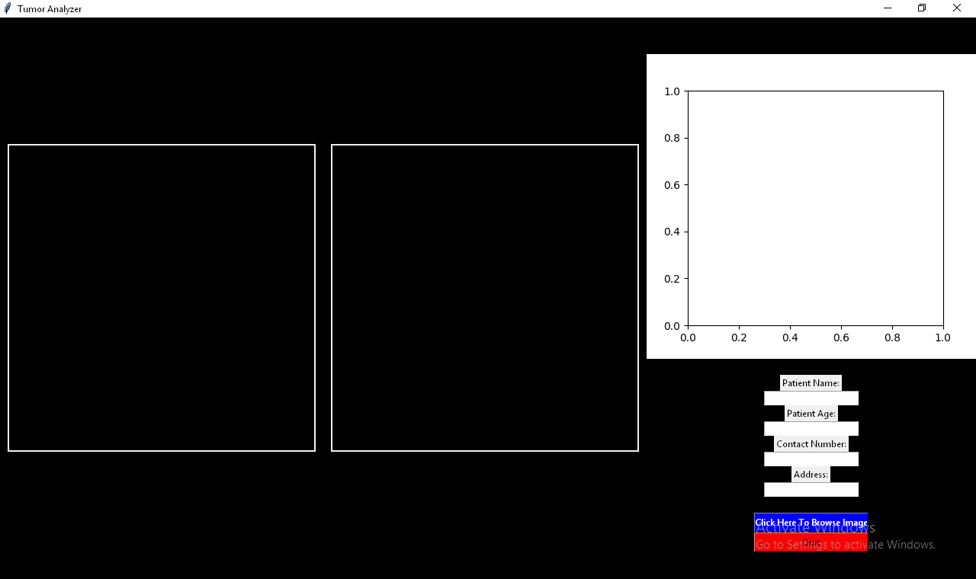

FILLING PATIENT DETAILS

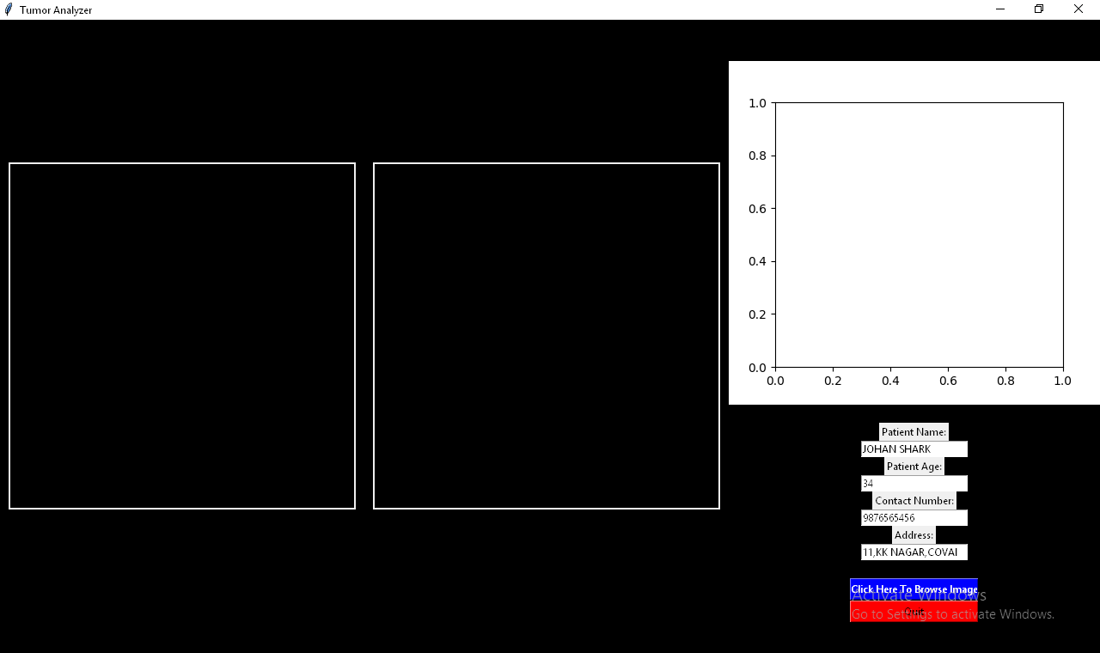

AFTER CLICKING BROWSE BUTTON

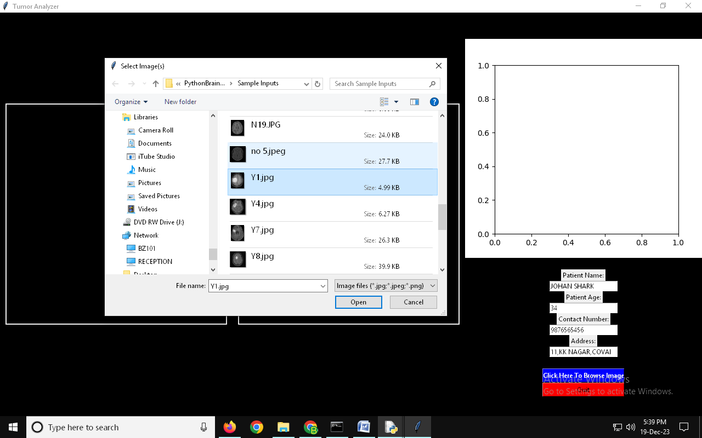

AFTER CHOOSING IMAGE RESULT IS SHOWN (TUMOR PRESENCE IN SIZE)

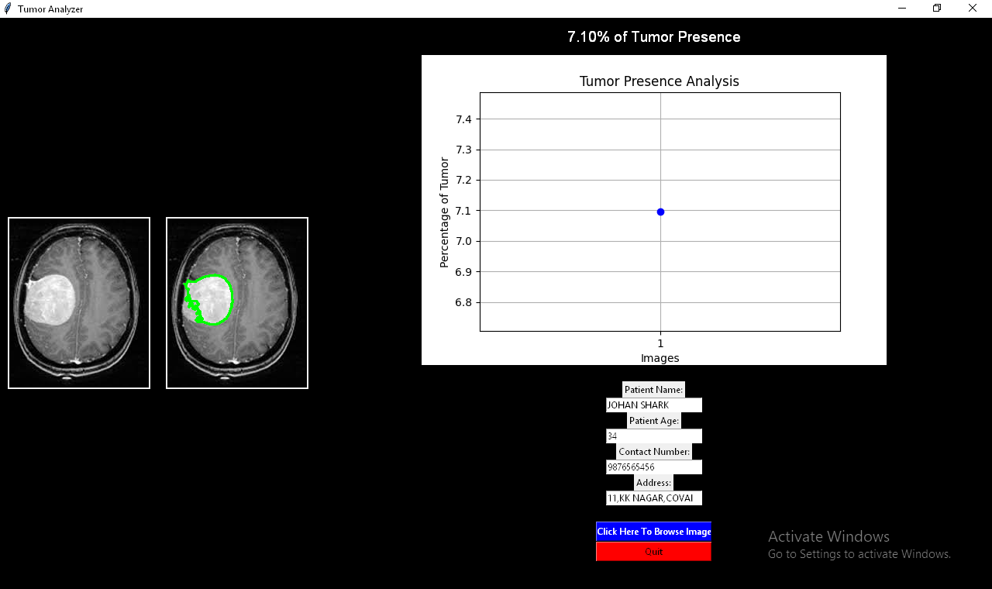

AFTER QUIT YOU CAN SEE THE DOCUMENT NAME WITH PATIENT NAME AND CONTACT

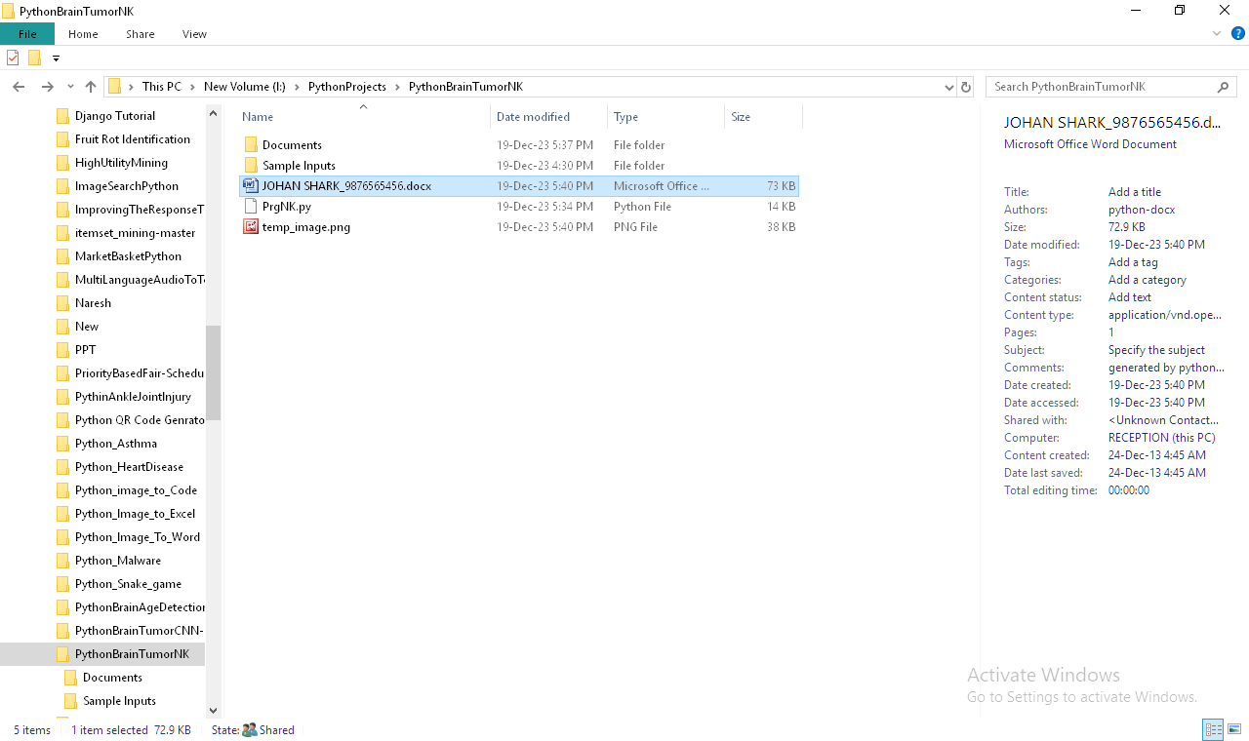

DOCUMENT CONTAINS SCANNED REPORT DETAILS

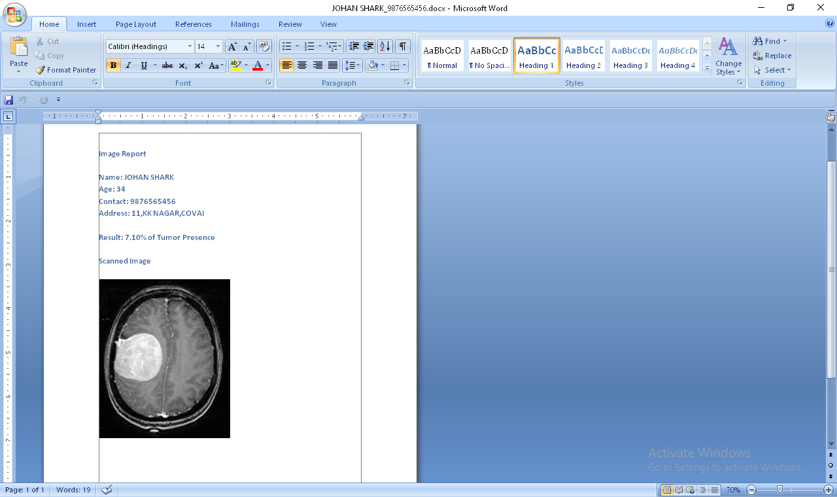

CONCLUSION

In conclusion, the "Brain Tumor Detection with Severity Identification Using K-Means Clustering" project presents a comprehensive and automated solution for the analysis of medical images, particularly brain scans, aimed at early tumor detection and effective treatment planning. Through the integration of OpenCV for image processing, contour detection, percentage calculation, graphical visualization using matplotlib, a user-friendly interface with Tkinter, and report generation with python-docx, the system provides a robust framework for healthcare professionals. By streamlining the identification process and offering quantitative measures of tumor presence, this system enhances the efficiency of medical image analysis. The combination of advanced technologies not only aids in early diagnosis but also facilitates trend analysis and comparison across multiple images, contributing to significant advancements in medical imaging and diagnostics. Ultimately, the project stands as a valuable tool for improving patient care and outcomes in the realm of neurological health.

FUTURE ENHANCEMENTS

Looking towards future enhancements, the "Brain Tumor Detection with Severity Identification Using K-Means Clustering" project could benefit from the integration of machine learning algorithms for more precise tumor classification and severity assessment. Implementing deep learning models, such as convolutional neural networks (CNNs), could enhance the system's ability to distinguish between benign and malignant tumors, providing more accurate diagnostic insights. Additionally, incorporating a larger dataset for training the models would contribute to increased robustness and generalization. Moreover, real-time image processing capabilities and integration with cloud-based storage could be explored to enable seamless collaboration among healthcare professionals and facilitate remote diagnostics. These advancements would not only bolster the system's accuracy and reliability but also position it at the forefront of cutting-edge technologies in the field of medical imaging and tumor detection.

REFERENCES

- Matthew Macdonald, Robert Standefer, “The Complete Reference”, February 21, 2002, PAPERBACK, McGraw-Hill Osborne Media.

- Greg Buczek, “Master the python programming language”, December 13, 2001, PAPERBACK, McGraw-Hill Osborne Media.

- Scott Mitchell, Donny Mack, Stephen Walther, Doug Seven, Bill Anders, “Tips, Tutorials and Code”, August 23, 2001, Book and CD-ROM edition, Sams.

- Danny Ryan, Tommy Ryan, “python image processing”, August 23, 2001, Book and CD-ROM edition, Visual.

- Dave Mercer, “Complete python with neural network”, December 20, 2001, 2nd edition, McGraw-Hill Osborne Media.

WEB REFERENCES

1. http://pythonheaven.com
2. http://www.codeproject.com
3. http://w3schools.com
4. https://www.pythontutor.net
4. python-informations.com/

